SET-10
19.Write a Pandas program to display the dimensions or shape of the World alcohol
consumption dataset. Also extract the column names from the dataset.
Code:
import pandas as pd
df = pd.read_csv("world_alcohol.csv")
print("Shape:")
print(df.shape)
print("\nColumn Names:")
print(df.columns)
Output:
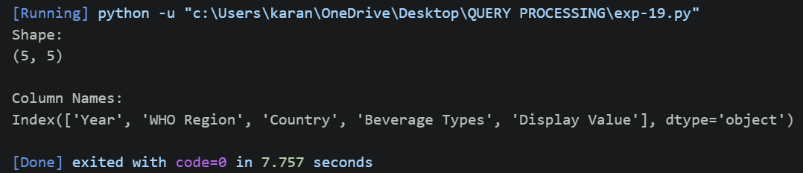
20.Write a Pandas program to find the index of a given substring of a DataFrame column.
Code:
import pandas as pd
data = {
"Name":["Apple","Banana","Mango","Orange"]
}
df = pd.DataFrame(data)
print(df["Name"].str.find("an"))
Output:
